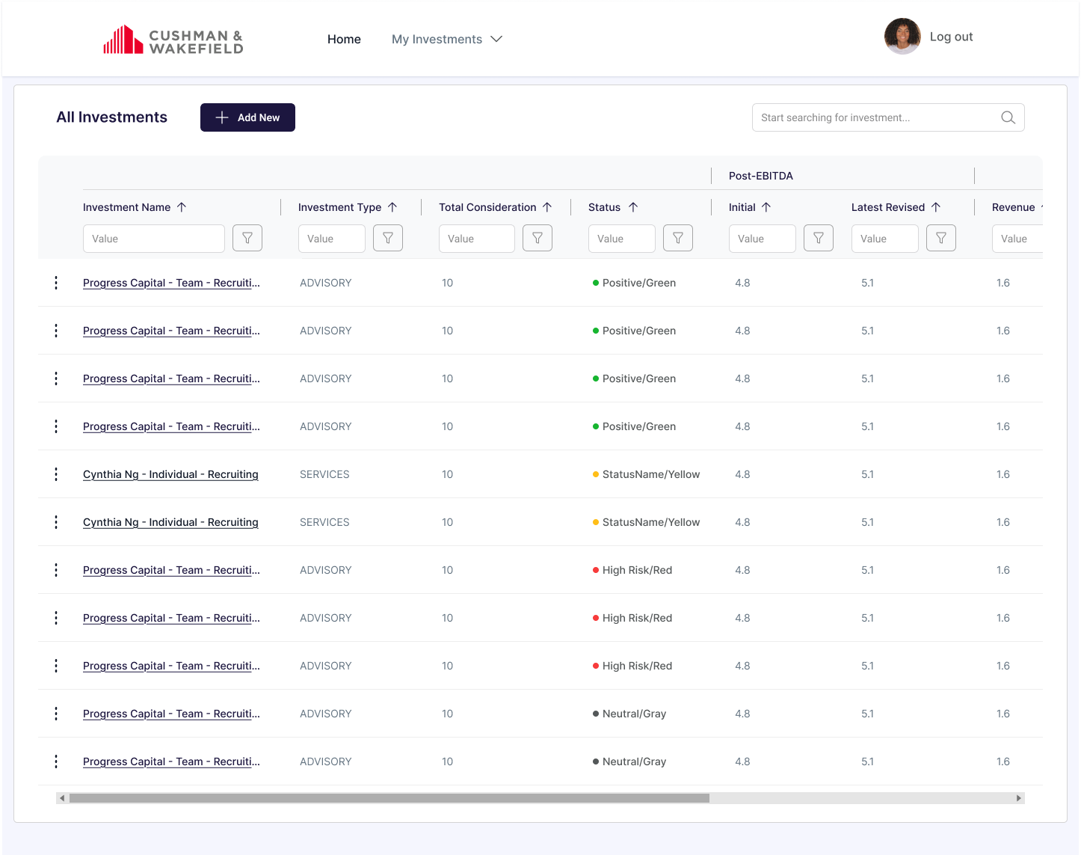

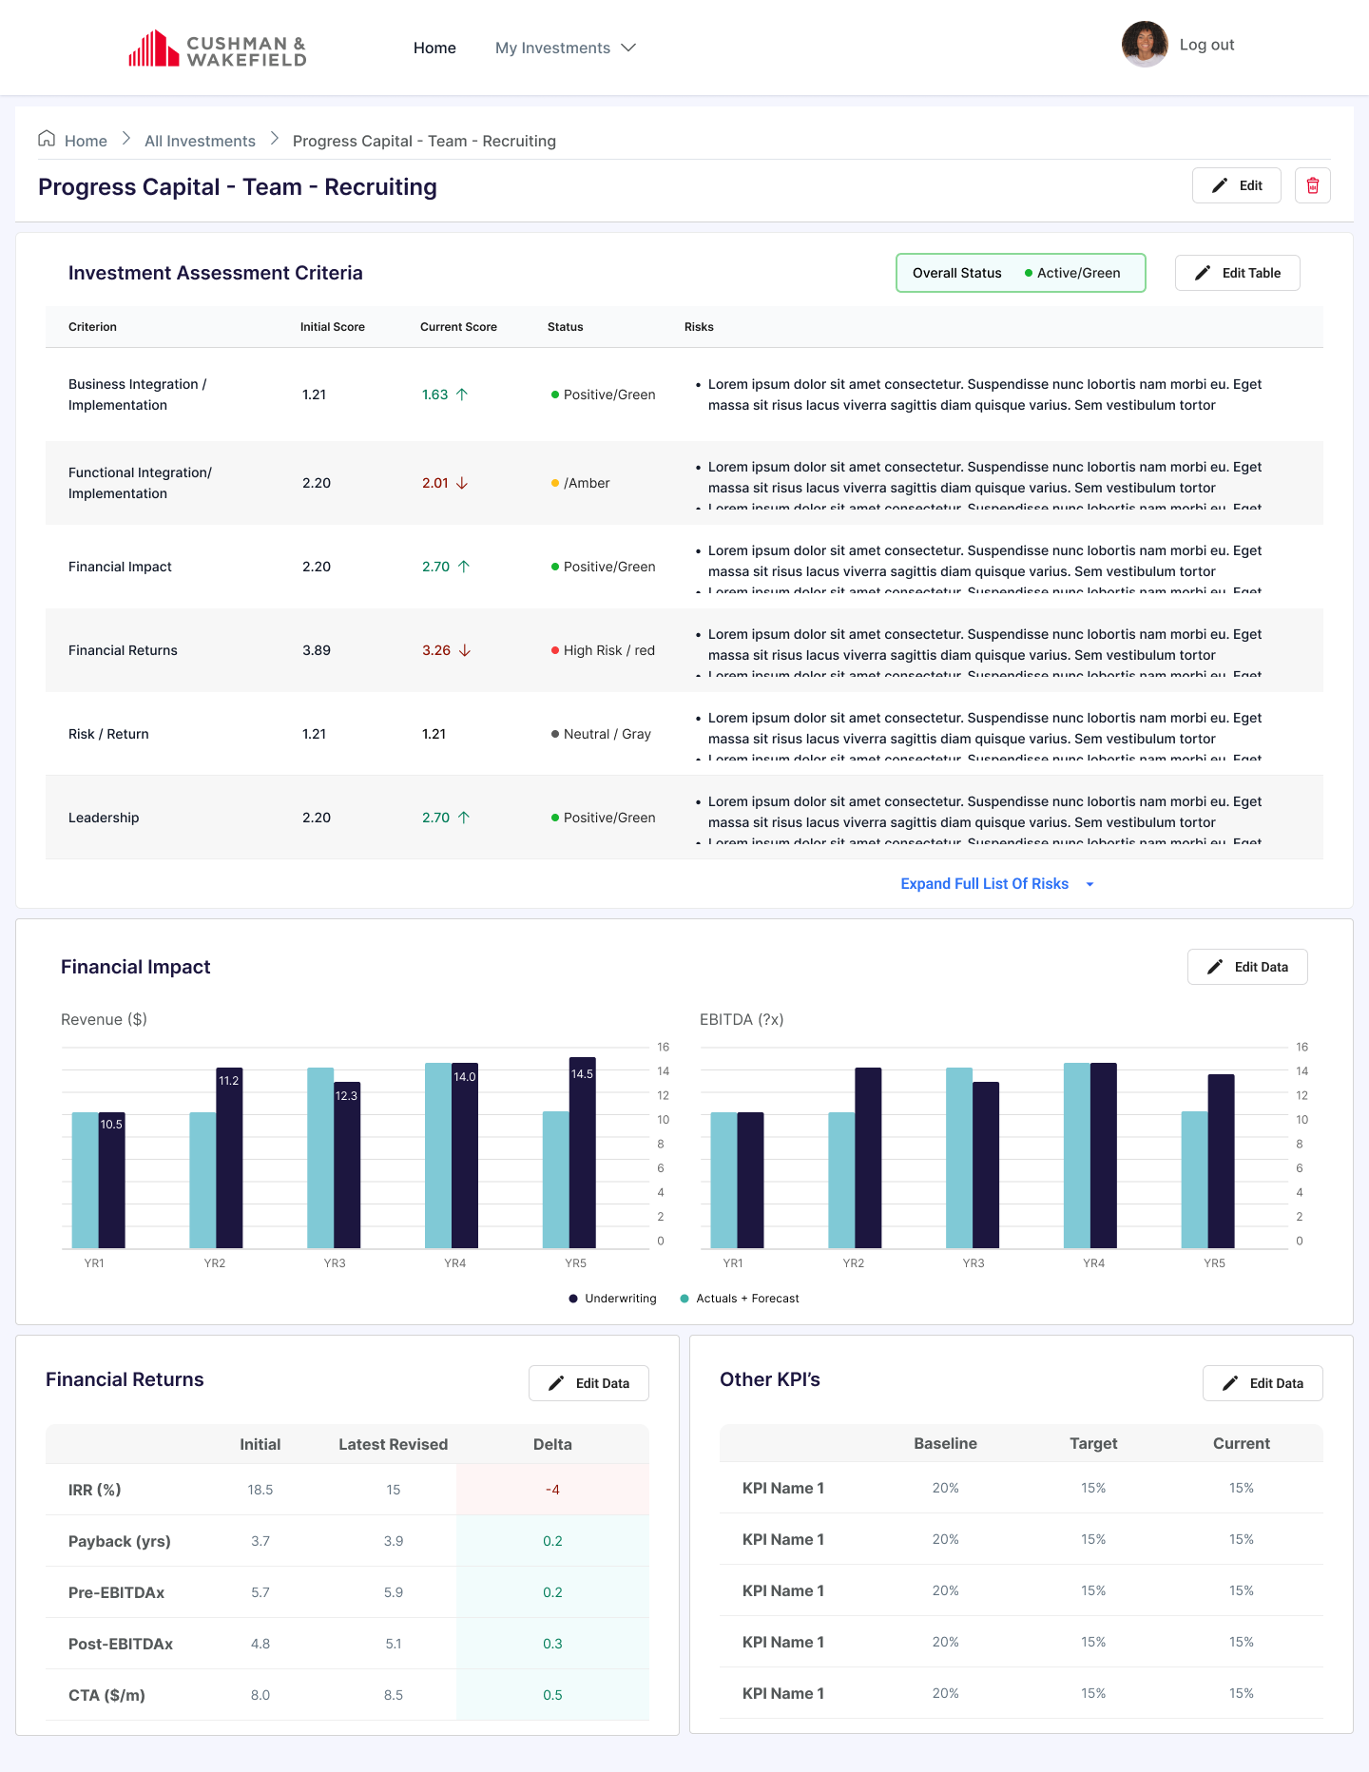

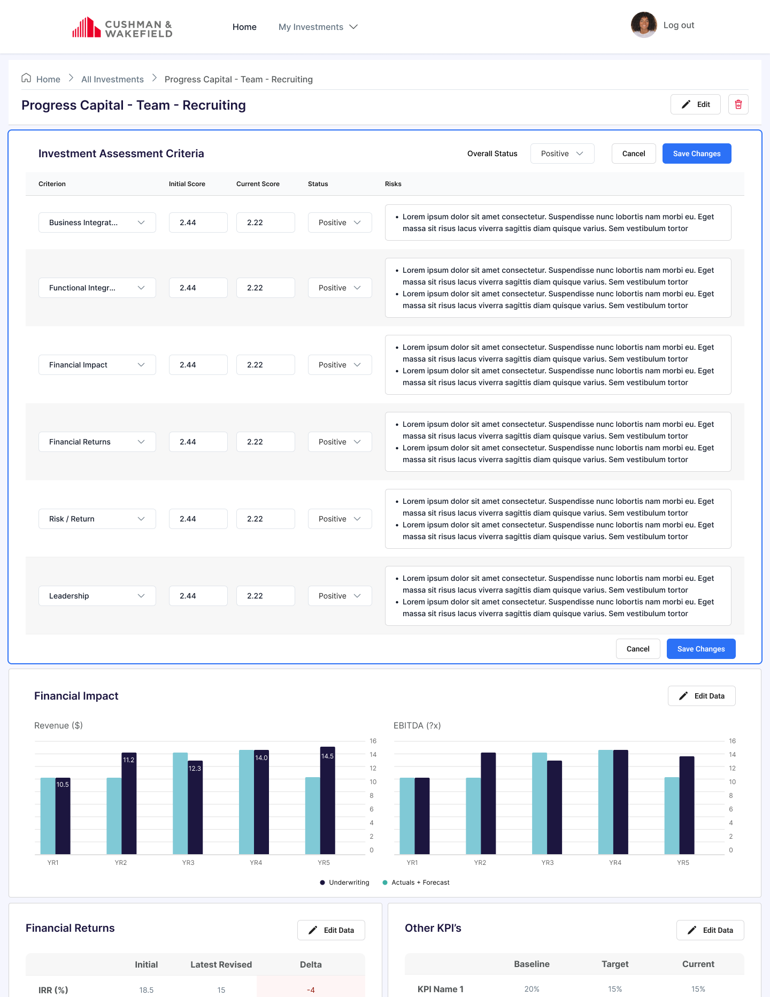

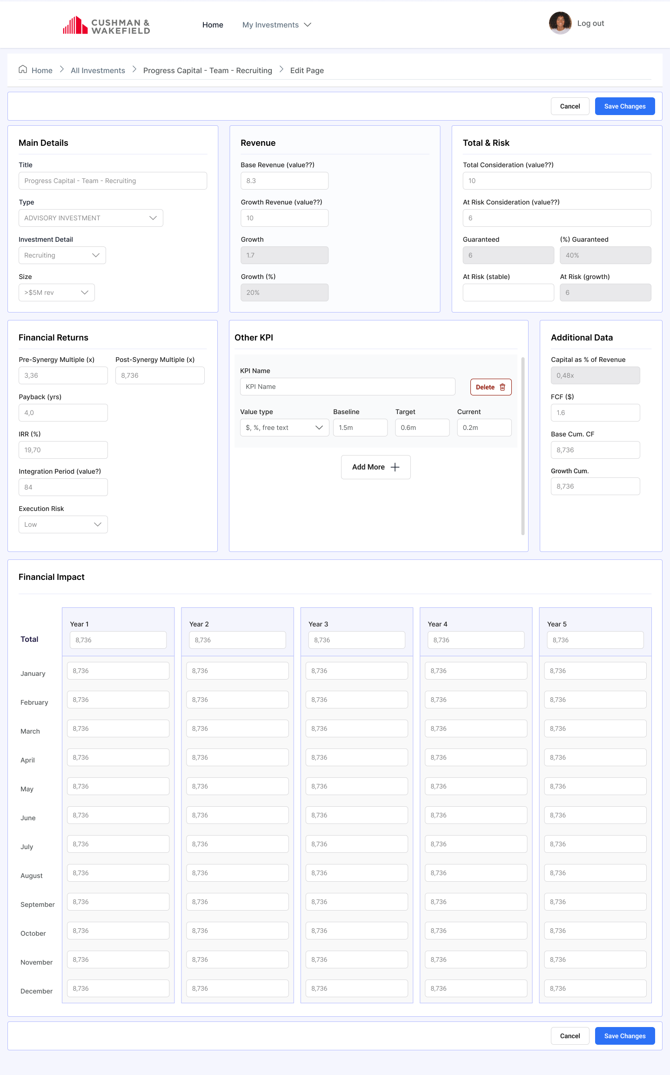

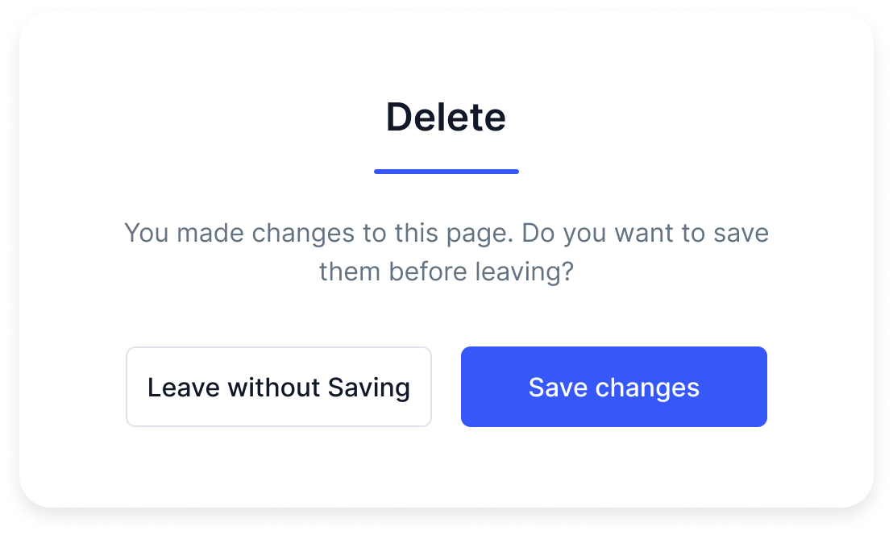

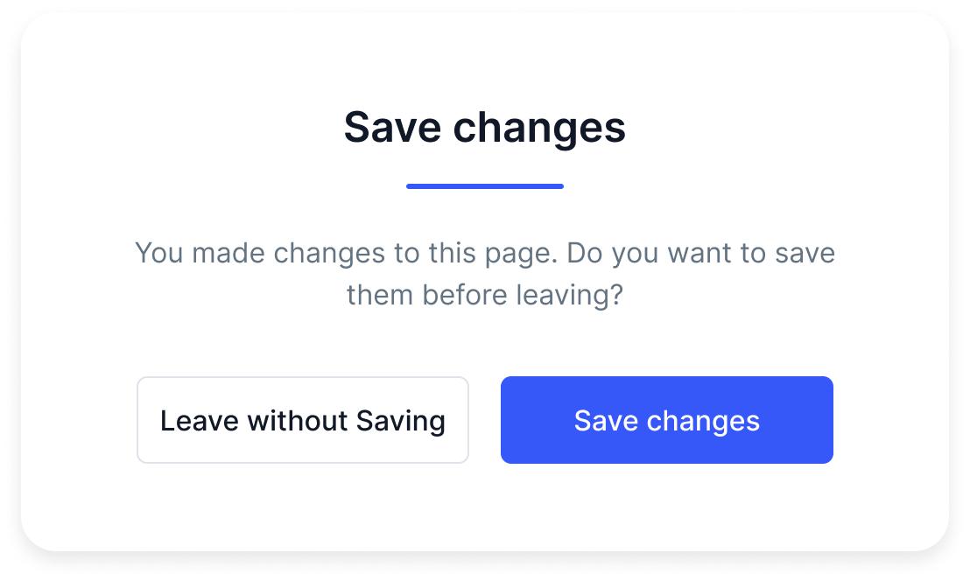

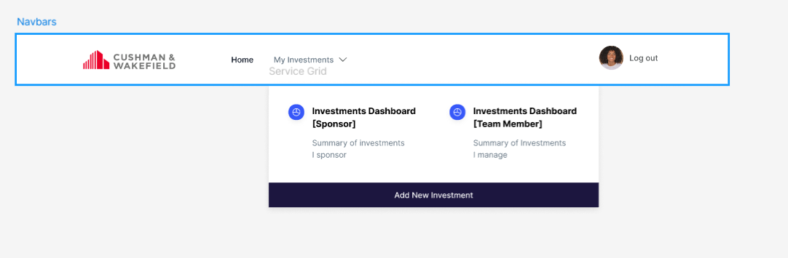

**Homepage**

1. use <https://www.ag-grid.com/example/> for our homepage table
2. On the topbar we have Photo of the user – we can leave a placeholder. (Joanna’s task: Sketch how the name and role displays)
3. Search bar should read  what’s in the table via keywords (Shilpa)
4. Apply background colors and buttons according to what is in the Figma (Shilpa)

**Investment Page**

1. “Expand Full list of Risk” applies only to the description (Shilpa)
2. Description is set to 160 characters before it expands. (Shilpa)
3. There are 6 rows, fixed (Shilpa)
4. “Edit Data” button is visible on all the cards, separately. It takes the user to the Edit Page (except Investment Assessment Criteria, it edits on the page) (Shilpa)
5. Save, Cancel, Delete notifications